Here’s what you need to know to get started with Anat Baniel Method® transformational neuromovement® sessions for your child
How do I get started?
The first step is to schedule an appointment for one or both parents to come in on your own. We’ll use this time to talk about your child and to give you a lesson similar to the one we expect to give your child at their first session. We have two goals for this:
- By experiencing changes yourself, you’ll know what to watch for during your child’s sessions, and how to help your child at home.
- You’ll leave feeling more limber, more hopeful, and more energetic. And don’t be surprised if some chronically stiff or sore parts of you feel significantly better!
Then choose a program that fits your goals. Some of our parents see their babies and children solve a specific problem and integrate the new movements into their life in a few sessions. Others enjoy watching their child continue to make progress over time in many areas of their life, so choose a program that allows more sessions.
We get the best results when 2-10 sessions are grouped together – often over a weekend or school break. For many children, two lessons in one day, with an hour or two between to eat and recharge, works well. Each lesson takes between 20 to 40 minutes, depending on the age and attention span of the child. Our goal is to fit the lessons into your life in the most effective way for your child.
After every session, we ask that you email us letting us know what progress you’re seeing, a quick snapshot of what else is happening in your child’s life, and any concerns you have for the next session. We prefer not to talk about the child in the child’s presence, and are happy to talk on the phone while the child is in school or in the evening after bedtime.
 | Description
Quick relief | 4 sessions over two weeks to work on a specific problem.
Get moving | 10 sessions to help your child make progress on goals and improve how they learn.
Ongoing growth | An ongoing relationship, with 5 or more sessions monthly.
** Start with any session or program, and when you upgrade to the next level program,
we’ll apply your first purchase.

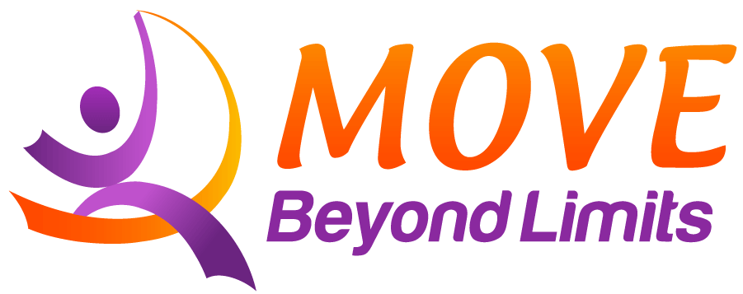 | “Making the impossible possible,  the possible easy,  and the easy elegant.”  Moshé Feldenkrais, DSc.

- Scheduling: We recommend grouping appointments together when possible. Scheduling two sessions a few days apart is more effective than spreading them a week apart, for example.
- No fragrances: Please do not use perfumes, oils, or scented lotions before coming in.
- Cancellation: Feel free to cancel if your child is sick, or had a particularly rough night and is short on sleep. There is no charge when this happens. (For other cancellations, we ask for at least 24 hours notice so we can give the time to another person).
- Referrals: When you hear a friend or family member talking about limitations due to stiffness or pain, please let them know about us. We see adults, infants, and children.
Some of the reasons adults and children come in:
- They love to run, hike, dance, ski, golf, walk, play soccer, etc. and want to do it easier.
- They’re feeling stiffness or pain or other movement restriction, and want to feel better.
- They’re recovering from an accident or surgery, or wanting an alternative to surgery.
- They have a neurologic condition impacting movement, such as Parkinsons,
cerebral palsy, multiple sclerosis, brain injury, or autism.
- They’re tired of feeling awkward.
- They want to prevent falls.
Infants and children also come in for delays reaching milestones, hypotonia, hypertonia, dyslexia, ADD, and other developmental concerns.
When you refer a friend who signs up for a program, you’ll get a free class.
We also very much appreciate your reviews on Yelp, NextDoor, and other social sites.
- Gift certificates: We offer gift certificates for children and adults, email or ask us when you’re in for a session. These are available for a special rate for existing clients and come with a lovely gift card, or, if you prefer, with a small box.
- Insurance: The Anat Baniel Method ® and the Feldenkrais Method® are considered somatic education, rather than a medical intervention. Some of our clients have been able to get their sessions covered by insurance or as part of a car-accident settlement. If you have an HSA account, you can use it to pay for sessions.
If you would like to bill insurance, after your program is complete, we’ll give you a receipt with the CPT code: 97112 Neuromuscular reeducation or 97140 Manual Therapy Technique, and our EIN 26-2418758, and NPI numbers (Ed Mills: 1831526367, Irene Pasternack: 1134556152) that you can submit. Ask your insurance provider if they cover Feldenkrais Method or Anat Baniel Method sessions, and which CPT code they prefer.
To improve the likelihood of insurance coverage, ask us for a referral form to give your physician.
How can I help my child get the most out of each session?
- Have your child arrive well-fed, and bring a snack. All this learning makes for a hungry child!
- Schedule sessions at the best time of day for your child, and when possible, avoid days without other therapies, particularly physical therapy.
- Watch for changes, big and small. Changes may be in areas that appear unrelated to the movements done in the lessons. When you notice a change, send us an email at info@movbeyondlimits.com. The act of noticing helps wire in the changes so that they last. And small changes add up to big ones!
- If possible, don’t bring young siblings to lessons. We have a large waiting room with Internet access, so older children can read or use a phone/tablet.
- After the session, if you have time, allow some time for free play. For an infant or toddler, being on the floor. For an older child, some time at a playground or park. This gives the child time to integrate their new abilities to find support from the ground.
- Read Kids Beyond Limits by Anat Baniel. Look for ways to include the 9 essentials in your child’s life.
What can I expect in the long term?
- You should see progress with each group of sessions. You’ll build your observation skills as part of the process. Typically children become more coordinated, more mobile, more independent, more verbal, and better learners. Often sleep improves as well.
- You’ll know it’s time for another set of lessons if your child asks for more, if you see a plateau in their acquisition of new skills, or you want to help them bump up their level of functioning in a new area. Some families choose do a mini-intensive one weekend a month, others cluster appointments during school breaks, and others find that a weekly appointment fits best.
- Let us know as priorities shift, and we’ll adjust the lessons accordingly.
How do I describe this to my family and friends?
- It’s a gentle, comfortable, and fun way to make everything a little easier.
- Kids whose movement has been restricted because of reflux, NICU time, brain injury or other reasons, miss some of the early parts of brain development that come from making sense out of random movement. This method helps the child learn to learn through movement, which often makes them a better learner in other areas as well.
- The Anat Baniel Method is based on the Feldenkrais Method. (To pronounce the name of the method, first say “Par-a-dise”. Then say “Feld-en-krice”.) The Feldenkrais Method is named after its creator, Moshé Feldenkrais, a physicist, engineer, and Judo black belt. Anat Baniel was an early student of Feldenkrais, and when he became incapacitated, she took over training future practitioners. He passed away in 1984. She currently practices in California.
- Both methods are used by adults and children to improve comfort and build skills at learning new movements. People of all ability levels benefit: they are often used by people with disabilities, athletes, and musicians, as well as anyone who wants to free themselves from restrictions and do more of what they love to do.

