How do I get started?
First, choose a program that fits your goals. Some of our clients solve their initial problem, learn how to prevent it, and leave happy after a few sessions. Others find that as they start feeling more limber and comfortable, their dreams begin to surface and they enjoy our help building new skills and continuing to feel younger and more fluid and flexible in body and mind.
Learning to use your body well is a lot like learning to play an instrument. Your skill at finding comfort and ease and feeling in control of your own comfort grows with practice.
Single session | 1 session to feel how quickly you can expand your range of motion, comfort, and balance.
Quick relief | 4 sessions over 2 weeks to learn how to relieve and prevent stiffness and pain.
Get your body back | 10 sessions to enjoy a comfortable, limber body and discover your own power to move toward comfort.
Get your life back | 20 sessions to expand your ability to learn new skills and dramatically improve what you can do physically.  Is there an activity you’d love to do, but pain, stiffness or lack of energy is preventing you from doing it? This program helps you find efficient use of your body, so you have more energy, and changes the way you think about learning.
Get younger | An ongoing practice of Feldenkrais through private sessions and classes to continue expanding your learning into new areas.
** Start with any program, and when you upgrade to the next level program,
we’ll apply your first purchase.
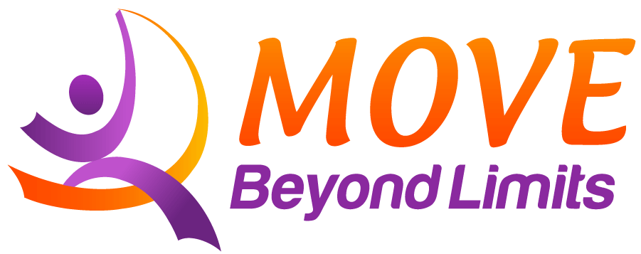 | “Making the impossible possible,  the possible easy,  and the easy elegant.”  Moshé Feldenkrais, DSc.

What else should I know?
- Scheduling: We recommend grouping appointments together when possible. Scheduling two sessions a few days apart is more effective than spreading them a week apart, for example.
- Dress in loose, comfortable clothes: Don’t wear jeans or tight clothes that might restrict movement. No skirts or low-cut tops please.
- No fragrances: Please do not use perfumes or scented lotions before coming in.
- Cancellation: If you need to cancel an appointment, please give us as much notice as possible, so we don’t turn away someone else. We charge for cancellations with less than 24 hours notice, except for emergencies.
- Referrals: When you hear a friend or family member talking about limitations due to stiffness or pain, please let them know about us. We see adults, infants, and children.
Some of the reasons adults and children come in:
- They love to run, hike, dance, ski, golf, walk, play soccer, etc. and want to do it easier.
- They’re feeling stiffness or pain or other movement restriction, and want to feel better.
- They’re recovering from an accident or surgery, or wanting an alternative to surgery.
- They have a neurologic condition impacting movement, such as Parkinsons,
cerebral palsy, multiple sclerosis, brain injury, or autism.
- They’re tired of feeling awkward.
- They want to prevent falls.
Infants and children also come in for delays reaching milestones, hypotonia, hypertonia, dyslexia, ADD, and other developmental concerns.
When you refer a friend who signs up for a program, you’ll get a free class.
We also very much appreciate your reviews on Yelp, NextDoor, and other social sites.
- Gift certificates: We offer gift certificates for children and adults, email or ask us when you’re in for a session. These are available for a special rate for existing clients and come with a lovely gift card, or, if you prefer, with a small box.
- Insurance: The Feldenkrais Method ® is considered somatic education, rather than a medical intervention. Some of our clients have been able to get their sessions covered by insurance or as part of a car-accident settlement. We accept HSA account payments.
If you would like to bill insurance, after your program is complete, we’ll give you a receipt with the CPT code: 97112 Neuromuscular reeducation or 97140 Manual Therapy Technique, and our EIN 26-2418758, and NPI numbers (Ed Mills: 1831526367, Irene Pasternack: 1134556152) that you can submit. Ask your insurance provider if they cover Feldenkrais Method sessions, and which CPT code they prefer.
To improve the likelihood of insurance coverage, ask us for a referral form to give your physician.
How can I get the most out of each session?
- After your session, if you have time, go for a short walk – even just once around our building. Sense your new fluidity. Look for echoes of your lesson in your body.
- Before bedtime, remember one or two movements from the session. Imagine doing them, looking for ease. Try the movement on both sides. See if the easier side can teach the other side how to make it easy. A few moments of any movement done carefully and well relaxes the entire nervous system, helps reset you into ease and can help you fall asleep!
- Watch for changes in your movement, comfort, emotions, sense of vitality, and behaviors. Changes may be in areas that appear unrelated to the movements done in the session. When you notice a change, send us an email at info@movebeyondlimits.com. The act of noticing helps wire in the changes, so that they last.
- Take it easy. Sometimes people get so excited by their new range of motion and comfort that they jump into a fast increase in what they love to do. Common sense still applies: increase gradually, so you can sense your body as you build your endurance.
What can I expect in the long-term?
- Expect to feel continually more graceful, coordinated, symmetrical, balanced, limber, and energetic - like you’ve found a way to turn the clock backward.
- People who do Feldenkrais regularly are less likely to trip and fall, they recover quicker from injuries, and they find it easier to do and expand their favorite activities.
- Increased optimism. Doing this method changes how you think about yourself. Instead of seeing yourself as having broken body parts, you’ll learn how to move in a way that helps you heal and feel good. Life, which may have contracted because of stiffness or pain, expands.
“What I’m after isn’t flexible bodies, but flexible brains.  What I’m after is to restore each person to their human dignity.”  Moshé Feldenkrais, D.Sc. | 
How do I describe this to my family and friends?
- It’s a gentle, comfortable, and fun way to make everything a little easier.
- It’s been around since the 1950s, and is used by adults and children to improve comfort and build skills at learning new movements. People of all ability levels benefit: it is often used for people with disabilities, athletes, and musicians, as well as anyone who wants to free themselves from restrictions and do more of what they love to do.
- It’s a mindfulness practice for the body: when you get good at sensing what you’re doing, it’s easier to change movement habits, so that you move in a way that brings comfort, pleasure, and continuing improvement.
- To pronounce the name of the method, first say “Par-a-dise”. Then say “Feld-en-krice.
It’s named after its creator, Moshé Feldenkrais, a physicist, engineer, and Judo black belt.

